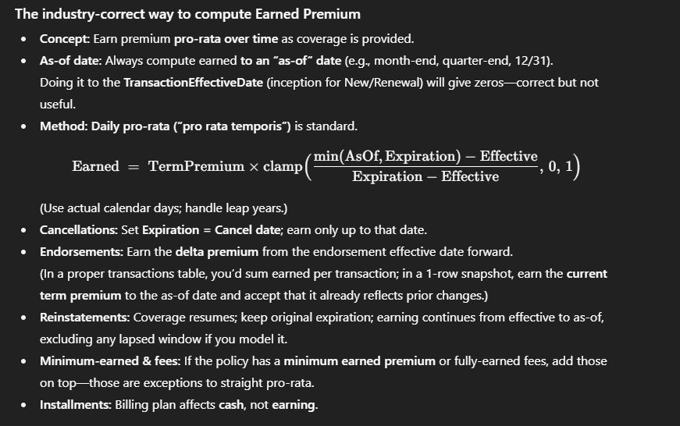

POLICY TABLE — COLUMN LOGIC (copy/paste)
- PolicyNumber: Unique PK generated as AAA9999999 (letters + digits) to ensure one row per policy in the snapshot table.
- CarrierCode: 4-letter carrier abbreviations drawn from a realistic list with skewed weights toward large carriers (e.g., TRAV, PRGS, GEIC).
- AgentCode: Six-digit numeric strings; pool size ~300 and distributed across policies (optionally guaranteed at least once per agent).
- TransactionType: Current-term transaction driving the snapshot, with realistic mix (Renewal/New majority; Endorse/Cancel/Reinstate/Rewrite rare).
- PolicyEffectiveDate: Start of the current term; sampled so that a 12-month term stays within the target window.
- PolicyExpirationDate: Set to Effective + TermLengthMonths (12); for Cancel, truncated to the CancellationDate (i.e., ends early).
- TransactionEffectiveDate: For New/Renewal/Rewrite equals PolicyEffectiveDate; for Endorse/Reinstate a mid-term date; for Cancel equals the cancel date.
- TermLengthMonths: Fixed at 12 to reflect standard annual policies (can vary later if you model 6-month Auto).
- LineOfBusiness: One of Personal Auto | Homeowners | BOP | WC | Umbrella | Package with realistic weights by market share.
- Subline: Mapped deterministically from LOB (e.g., Personal Auto → “Private Passenger Auto”, HO → “HO3”, BOP → “Businessowners”).
- InsuredName / InsuredPrimaryEmail: Faker-generated full name with a consistent email pattern (first.last@domain).
- RiskLocationAddress / State: US street address and two-letter state for the rated risk location; drives property/auto rating context.
- InsuredMailingAddress: Same as risk address ~80% of the time; otherwise a different, plausible address (reflecting PO Box/office scenarios).
- RatedDriverCount: Populated only for Personal Auto (typical 1–4, centered around 2); blank/NA for other LOBs.
- VehicleCount: Populated only for Personal Auto (typical 1–3, centered around 2); blank/NA for other LOBs.
- DwellingYearBuilt: Populated only for Homeowners using a realistic distribution skewed to 1990–2015; blank/NA for other LOBs.
- ConstructionType: Populated for Homeowners/BOP/Package (Frame, Masonry, etc.) using realistic mix; blank/NA for WC/Umbrella.
- ProtectionClass: ISO PPC score 1–10 (lower is better), centered around 5–7; only for Homeowners/BOP/Package.
- Limit_BI: For Personal Auto only; split BI limits chosen from common combos (25/50, 50/100, 100/300, 250/500, 500/500) with 100/300 most common.
- Limit_PD: For Personal Auto only; chosen from typical PD limits (25k–500k) with 100k most common.
- Deductible_Collision / Deductible_Comprehensive: For Personal Auto only; drawn from {250, 500, 1000, 2500} with 500/1000 most common.
- TermPremium
The full price for the current policy term (usually 12 months), after all changes; i.e., the “sticker price” for the entire term.
- WrittenPremium
Transaction-basis amount for the current row’s TransactionType:
New/Renewal/Rewrite = TermPremium; Endorsement = change only (± delta vs prior); Cancel = negative unearned at cancel date; Reinstate = 0.
- EarnedPremium
Portion of the TermPremium earned pro-rata by days of coverage up to the portfolio AS_OF date (capped between PolicyEffectiveDate and PolicyExpirationDate); cancels stop earning on the cancel (expiration) date.
- UnearnedPremium
The remaining part of the TermPremium not yet earned at the AS_OF date:
UnearnedPremium = TermPremium − EarnedPremium.
- BillingPlan: Direct Bill (~70%) vs Agency Bill (~30%) to reflect common billing arrangements.
- CancellationDate: Set only when TransactionType=Cancel (equals TransactionEffectiveDate) and forces PolicyExpirationDate to that date.
- ReinstatementDate: Set only when TransactionType=Reinstate (equals TransactionEffectiveDate) within the same term.
- RewriteIndicator: True only when TransactionType=Rewrite.
- eDocIndicator: True/False via probabilistic adoption by LOB, nudged by BillingPlan (Direct Bill slightly higher e-doc uptake).

COMMISSION TABLE — COLUMN LOGIC (copy/paste)
- CarrierCode / AgentCode: Carried over from policy to align the commission line with the producing carrier/agency.
- StatementDate: Month-end of the transaction (or effective) date to mimic carrier statement cycles.
- PolicyNumber: FK join to Policy; enables 1-to-many (multiple commission lines per policy over time).
- TransactionType: Mirrors the policy transaction that generated the commission (New, Renewal, Endorsement, Cancel, Audit, ReturnPremium, etc.).
- WrittenPremium: Basis for commission—full term for New/Renewal/Rewrite; delta only for Endorsement; negative unearned for Cancel (return premium); zero for Reinstate; optional ± audit delta for WC/BOP/Package.
- CommissionPercent: LOB-based street commission drawn from realistic bands (e.g., PA ~10–14%, HO ~8–18%, BOP/Package ~8–20%, WC ~5–15%).
- CommissionAmount: Calculated as WrittenPremium × CommissionPercent (rounded to cents); negative when basis is negative.
- DueDate: Set ~15 days after StatementDate to mimic typical carrier remittance timing.
- ReversalIndicator: True when CommissionAmount is negative (chargeback/reversal due to cancel, negative endorsement, or adverse audit).
Claims table
- CarrierCode — Copied from the linked policy to keep carrier attribution consistent for joins and rollups.
- AgentCode — Copied from the linked policy; treat (CarrierCode, AgentCode) as the unique producer identifier.
- PolicyNumber — FK to policy.PolicyNumber; each policy can have zero, one, or multiple claims (1→many).
- ClaimNumber — Unique ID in the form YYYY-######, where YYYY = loss year; numbers are assigned in loss-date order to guarantee uniqueness.
- LossDate — Random date inside the policy term (PolicyEffectiveDate..PolicyExpirationDate) to ensure time-valid losses.
- ReportDate — LossDate plus a short reporting lag (typically 0–7 days, occasionally longer), reflecting real reporting behavior.
- ClaimStatus — Determined from claim age and randomness: older claims more likely Closed; a small portion of closed claims become Reopened.
- CauseOfLoss — Drawn from LOB-specific distributions (e.g., Auto: Collision/Glass/Theft/Weather; HO: Wind/Hail/Water/Fire; WC: Strain/Sprain/Slip, etc.).
- LossLocation — Address in the same state as the policy; for Homeowners it’s usually the insured risk address, while Auto/BOP/WC/Umbrella/Package usually use a different in-state address (accident/job site).
- PaidLossAmount — Indemnity paid to date; for Closed claims equals the indemnity portion of the ultimate, for Open/Reopened is a fraction that grows with claim age.
- PaidExpenseAmount — ALAE (allocated loss adjustment expense) paid to date; modeled as a realistic share of total ALAE and generally paid earlier than some indemnity.
- ReserveLossAmount — Current indemnity reserve; zero for Closed claims, positive for Open/Reopened and sized so that Paid + Reserve ≈ ultimate indemnity.
- ReserveExpenseAmount — Current ALAE reserve; zero for Closed claims, positive for Open/Reopened and sized so that Paid + Reserve ≈ ultimate ALAE.
- CloseDate — For Closed claims, a date between ReportDate and (typically) within ~7–180 days of reporting, capped by the policy term end.
- ReopenDate — For a small share of closed claims, a reopen date shortly after CloseDate, within the policy term window; status becomes Reopened and reserves reappear.
- AdjusterContact — Faker-generated adjuster name and phone (format “J. Smith, 555-222-3333”) for realism.
- How many claims per policy? — Frequency is LOB-driven (Poisson per term; many policies have 0 claims, some 1+, capped to avoid outliers), producing a realistic portfolio distribution.

RetentionRate
Definition
Share of policies eligible to renew in the period that actually renewed into a new term.
Logic
- EligibleForRenewal (denominator): Count policies with PolicyExpirationDate in [PERIOD_START, PERIOD_END + 1 month buffer].
- Renewals (numerator): Count policies with TransactionType = "Renewal" and PolicyEffectiveDate in [PERIOD_START, PERIOD_END].
- RetentionRate = Renewals / EligibleForRenewal.
- Rounding: 2 decimals (e.g., 0.87).
- Edge rules: If EligibleForRenewal = 0, set RetentionRate = blank/NaN.
Data sources
policy.csv (PolicyEffectiveDate, PolicyExpirationDate, TransactionType).
Notes
- The 1-month buffer on expirations is a practical adjustment for 12-month terms that start near the period start and expire just after the period end.
- If you have prior-year data, you may optionally use an effective-date cohort (terms starting 12 months before the period) as the denominator.

LossRatio
Definition
Ratio of incurred loss to earned premium for the period.
Logic
- IncurredLoss (numerator): Sum of PaidLossAmount + ReserveLossAmount for claims with LossDate in [PERIOD_START, PERIOD_END]. (ALAE excluded; use loss only.)
- EarnedPremium (denominator): Sum of policy TermPremium earned pro-rata by day over the overlap between [PolicyEffectiveDate, PolicyExpirationDate] and [PERIOD_START, PERIOD_END].
  - Earned(policy) = TermPremium × (overlap_days / term_days)
- LossRatio = IncurredLoss / EarnedPremium.
- Rounding: 2 decimals.
- Edge rules: If EarnedPremium = 0, set LossRatio = blank/NaN.
Data sources
claims.csv (PaidLossAmount, ReserveLossAmount, LossDate) + policy.csv (PolicyEffectiveDate, PolicyExpirationDate, TermPremium).
Notes
- Cancels are already reflected: we truncated PolicyExpirationDate to CancellationDate in policy logic, so earned stops at cancel.
- If you want ALAE-inclusive ratio, add (PaidExpense + ReserveExpense) to the numerator.

CommissionRatio
Definition
Share of commission relative to the written premium basis posted in the period.
Logic
- CommissionAmount (numerator): Sum of CommissionAmount on commission lines with StatementDate in [PERIOD_START, PERIOD_END].
- CommissionWrittenPremium (denominator): Sum of WrittenPremium on those same lines. (Includes negatives from cancels and deltas from endorsements.)
- CommissionRatio = CommissionAmount / CommissionWrittenPremium.
- Rounding: 2 decimals.
- Edge rules: If |CommissionWrittenPremium| < $100 (guard) then set CommissionRatio = blank/NaN to avoid noise from tiny denominators.
Data sources
commission.csv (StatementDate, CommissionAmount, WrittenPremium).
Notes
- This is a transaction-basis measure and will differ from a term snapshot.
- If you want to reflect agency bill vs direct bill timing, change the posting rule (e.g., use DueDate or paid-date when available).

RewrittenPolicyRatio
Definition
Rate at which rewrite transactions occur relative to new business in the period.
Logic
- RewriteCount (numerator): Count policies with TransactionType = "Rewrite" and TransactionEffectiveDate in [PERIOD_START, PERIOD_END].
- NewCount (denominator): Count policies with TransactionType = "New" and TransactionEffectiveDate in [PERIOD_START, PERIOD_END].
- RewrittenPolicyRatio = RewriteCount / NewCount.
- Rounding: 2 decimals.
- Edge rules: If NewCount = 0, set RewrittenPolicyRatio = blank/NaN.
Data sources
policy.csv (TransactionType, TransactionEffectiveDate).
Notes
- “Rewrite” indicates moving/reissuing a policy (often to a different program/form) as new business; tracking it against New shows quality of new placements and carrier fit.

• Loss Ratio (lower is better)
How much the agency’s losses were relative to premium.
Formula: Loss Ratio = Incurred Losses / Earned Premium
From:
- claims.csv: losses (Paid + Reserve = Incurred), filtered by DateOfLoss
- policy.csv: Earned Premium (we prorate the policy premium across its term and take only the overlapping days in the window)
• Retention Rate (higher is better)
Of policies that expired in the window, what % renewed (ideally with same agency).
From: policy.csv using any of:
- TransactionType == "Renewal" or IsRenewal == True, or
- mapping EXPIRINGPOLICYNUMBER → POLICYNUMBER (best), or
- a fallback heuristic (renewal within X days after expiration).
• Submission Quality / Hit Ratio (higher is better)
How many submissions/quotes turned into bound policies.
Formula: Hit Ratio = #Bound / #Submitted (or #Bound / #Quoted)
From: policy.csv if you have columns like Submitted, Quoted, Bound.
If your data doesn’t have these, this metric is dropped (weights get rebalanced if you checked that box).

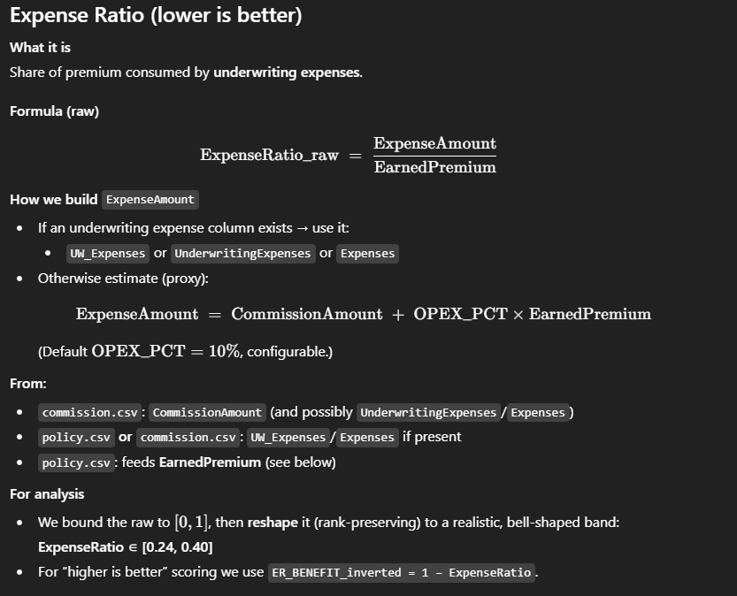
• CC (Closeness Coefficient)
The final TOPSIS score from 0 to 1.
- 1.0 = exactly like the “ideal” combo (best for each metric)
- 0.0 = exactly like the “worst” combo (worst for each metric)
Agencies are ranked by CC (higher = better overall balance).
Ranges used in analysis (current build)
KPIs used for ranking (inputs):
- RetentionRate → [0.50, 0.95] (rank-preserving remap; higher is better)
- LossRatio → [0.30, 0.90] (rank-preserving remap; we score with 1−LossRatio1-\text{LossRatio}1−LossRatio)
- ExpenseRatio → [0.24, 0.40] (rank-preserving remap; we score with 1−ExpenseRatio1-\text{ExpenseRatio}1−ExpenseRatio)
- SubmissionQuality → bounded to [0.20, 1.00] (higher is better)

